Version 25/02/2011
ESPON Climate:
Climate Change and Territorial Effects on Regions and Local Economies
Applied Research Project 2013/1/4
Draft Final Report
Annex 4 Case Study Mediterranean Coast of Spain
David Sauri
Jorge Olcina
Hug March
Javier Martín-Vide
Fernando Vera
Emilio Padilla Anna Serra-Llobet

Contents
Summary 3
- Introduction 4
- The study area: a brief presentation 7
- Methodological outline 8
- Vulnerability assessment 11

- Exposure 11
- Sensitivity 14
- Impact 23
- Adaptive capacity 24
- Vulnerability 29

- Response strategies and policy development 31
- Validity for the Pan-European assessment 31
- Value added and lessons learned 32
- Transferability of case study results or methodology 33
- Conclusions 33 References 34
1

List of figures
Figure 1. Map of the study area with the location of the different tourist zones 8
Figure 2. Dimensions included in the vulnerability index with the respective weights and
the variables used 10
Figure 3. Map of decrease in available water resources around 2050 with respect to
average values for 1961-1990 (Exposure) 14
Figure 4. Population of the tourist zones (2009) 15
Figure 5. Population growth in the tourist zones (percent) (2000-2009) 16
Figure 6. Map of population growth in the study area (percent) (2000-2009) 16
Figure 7. Map of number of beds in hotels and apartments (2008) 18
Figure 8. Number of tourists in the different tourist areas (2008) 18
Figure 9. Urban land in the different tourist areas (km²) (2006) 19
Figure 10. Map of urban sprawl in the different tourist areas expressed as
percentage of disperse urban land/total urban land (2006) 19
Figure 11. Water consumption in the different tourist areas 20
Figure 12. Map of water consumption in the different tourist 20
Figure 13. Number of jobs in hotels of the different tourist areas 21
Figure 14. Map of jobs in the hotel industry (2008) 21
Figure 15. Map of combined sensitivity to climate induced water shortages 22
Figure 16. Map of impacts of climate induced water shortages in tourist areas
of the Spanish Mediterranean coast 23
Figure 17. Trends in water consumption per capita 25
Figure 18. Desalination capacity in the different tourist areas (hm³) 26
Figure 19. Percent of water reuse of treated wastewater 26
Figure 20. Average regional income per capita (Euros) 27
Figure 21. Map of average regional income (Euros) 27
Figure 22. Map of adaptive capacity of the different tourist areas 28
Figure 23.Aggregated vulnerability map to climate induced water shortages 30
List of tables
Table 1. Weighted values of components and subcomponents of vulnerability 9
Table 2. Components, subcomponents and variables for assessing the vulnerability
10
Table 3. Decrease in average runoff in the Jucar and Segura basins, 13
Table 4. Qualitative summary of components of the vulnerability assessment 29
2

Summary
The Mediterranean coast, together with the Balearic Islands, is the most important tourist area of Spain and a key pillar of the Spanish economy. Climate is a fundamental constituent, and perhaps the key influencing factor in explaining the attractiveness of this area for domestic and international tourists. According to the latest IPCC report (2007), average temperatures in the Mediterranean basin may increase substantially during the 21st century while precipitation may decrease thus limiting the amount of water available for human and non human uses.
The objective of this case study is to perform a vulnerability assessment to possible water shortages induced by climate change in the tourist areas of the Spanish Mediterranean coast. In order to produce such an assessment we have used variables related to exposure (water availability after changes in temperature and precipitation); sensitivity (characteristics of the tourist sector), and adaptive capacity (water supply alternatives, income). Te relative weighing of each variable has been determined from a Delphi panel composed by ESPON experts.
Results show a distinct spatial pattern according to the combined dimensions of exposure, sensitivity and adaptive capacity. Generally, vulnerability tends to increase from North to South, mainly because of increasing exposure and decrease in adaptive capacity (especially in what concerns income) along this gradient. One extreme case is the Costa del Sol tourist area (one of the most important not only of Spain but of the entire Mediterranean) where scores for exposure, sensitivity and adaptive capacity combine to produce the highest vulnerability of the study area. At the opposite side, certain areas of Catalonia observe low vulnerabilities after a combination of low exposure and high adaptive capacity. Another interesting case are the Balearic Islands which rank low in exposure but medium to high in sensitivity thus indicating the strategic importance of tourism for the economy of the archipelago. Adaptive capacity, however, is in principle high enough to offset sensitivity. Hence, the resulting vulnerability is low.
The variables selected and the method chosen may be useful for other tourist areas of the Mediterranean coast. Generally, one could assume an increase in the vulnerability of Mediterranean tourist areas along a gradient West-East due to increasing exposure, perhaps medium to high sensitivity (due to the enormous growth of the tourist industry in certain areas such as the Balkans or the Eastern coasts), and low to medium adaptive capacities which may change in the future if alternatives such as desalination (already present and growing in many Mediterranean countries) can be implemented. However, sound adaptive capacities should move towards better water demand management (to an important extent only possible through the management of urban-tourist growth). However and as seen in the case of Spain, this alternative is still in its infancy.
3

1. INTRODUCTION
The Mediterranean coast, together with the Balearic Islands, is the most important tourist area of Spain and a key pillar of the Spanish economy. Climate is a fundamental constituent, and perhaps the key influencing factor in explaining the attractiveness of this area for domestic and international tourists. Therefore, climate change must necessarily be an issue of concern for the tourist sector and, more generally, for the well-being of the population. One of the most important challenges faced by Mediterranean societies during the last millennia is how to adapt to erratic precipitation patterns that are best represented by extremes (drought and flood) than by averages. Furthermore, this adaptation needed to tackle a fundamental constraint in this area: under natural conditions water availability tends to be at its lowest in summer when human and non human (agricultural) demand is at its highest.
According to the latest IPCC report (2007), average temperatures in the Mediterranean basin may increase substantially during the 21st century. Precipitation may decrease thus limiting the amount of water available for human and non human uses. Moreover, economic activities such as tourism may be affected by heat waves and flood episodes as well as by storm surges that damage beaches and may force the construction of costly infrastructures. Of all these potential impacts of climate change we have chosen to focus on water resources because of their strategic importance for tourism. Water is, of course, fundamental for life and economic activity, and tourism is no exception. Furthermore, water availability in quantity and quality remains essential in any tourist package, especially those related to beach mass tourism in summertime. To give just an example on how water can be critical in this respect, we may recall how German tourism abandoned the tourist centre of Benidorm en masse because of the water shortages experienced in this city during 1977 and 1978 (Gil Olcina, 2010). Water is also a lens through which we may examine different adaptation strategies to climate change (changing consumption habits, “production” of new resources), and finally, water can also help us to unravel how these adaptation strategies may depend on the ways by which certain economic sectors such as tourism tend to develop spatially. In other words, how adaptation to water stress induced by climate change varies according to the spatial imprint of certain forms of tourist development. This may be an issue of special relevance for ESPON projects.
The case study presented in this report explores three inter-related themes on the likely impacts of climate change on the Spanish tourist industry. First, temperature and precipitation patterns are evaluated in order to unravel future trends regarding the availability of water, especially whether extreme events (droughts and floods) are to be expected. Preliminary results indicate that a reduction in precipitation is likely especially during the warmest months of the year. The second theme concerns an analysis of the recent development of urban land uses related to tourism (hotels, apartments, villas, campsites, etc.). This analysis is very relevant because exposure and vulnerability to water scarcity change according to each different modality of tourism (“mass” beach
4

hotels versus golf resorts, for instance) and because, in turn, each modality adjusts o adapts to these new climatic conditions in different ways. We already have some results for the case of Benidorm showing, for instance, that water consumption per capita in villas may be higher than water consumption in hotels, and much higher than water consumption in campsites (Rico et al., 2009). The third theme focuses on existing and potential water resources in the study area classified according to their origin. We have assessed the role of water desalination or water re-use as adaptive tools to become “climate independent”. Finally, and in consonance with the ESPON Climate project, our vulnerability assessment will consider both the potential impacts induced by climate related water scarcity, and the adaptation measures taken.
Climate change, water resources and tourism: some basic relations
During the last decade, the relationships between tourism and climate change have received increasing attention. For example, the number of scientific publications on this topic doubled between the years 1996-2000 and 2001-2005, and continues to grow. Moreover, there have been some 20 international conferences and scientific meetings between 2003 and 2009 dealing with these interlinked issues. As perhaps the most relevant event, in October 2007, Davos (Switzerland) hosted the Second Conference on Climate Change and Tourism.
If the Djerba conference of 2003 and the subsequent declaration did not have a significant impact at the international level, the Davos conference included the presentation of what is perhaps the most comprehensive report on climate change and tourism to date. This report was a joint effort by the United Nations Environment Programme, the World Tourism Organization, and the World Meteorological Organization. The report begins by summarizing the main conclusions of the IPCC report of 2007 and states that, like all other economic activities, tourism will have to face the challenge of climate change through adaptation and mitigation measures. Very much like agriculture, tourism appears to be sensitive to climatic conditions but in contrast to agriculture and to other economic activities as well, it also appears to have an important adaptability and resilience to new situations because it has been able to overcome serious challenges such as terrorist attacks, infectious diseases or natural calamities like the Asian tsunami of 2004. Nevertheless, the report also warns of the need to anticipate possible adjustments to what may be totally unexpected events (for instance, the exceptionally warm winter of 2006-2007 in the Alps or the European heat wave of 2003). There were also some concerns about the tendency to overestimate the adaptive capacities through technological improvements such as artificial snow or desalinated water.
Another remarkable conference that focused specifically on the Mediterranean was "Coastal Tourism in the Mediterranean: Adapting to Climate Change" held in Cagliari (Sardinia) in June 2009 with an outstanding participation of the World Tourism Organization. Similarly, some research projects of the European Union (for instance, the "Peseta" project) have dealt with the impacts of climate change on tourism.
5

Despite the multiplication of initiatives, the tourist sector has yet to improve its awareness of the challenges posed by climate change. A possible cause of this is the major uncertainties surrounding the availability and reliability of climate change scenarios at local and regional level (Dubois and Ceron (2006). Without these scenarios, the high degree of uncertainty accompanying the more general estimates (for instance, a 10 percent decrease in snow cover may involve a reduction of between 10 and 30 percent in the number of skiers) makes very difficult to generate new information that may be useful for decision making. Regarding mitigation, it is acknowledged that tourism contributes to climate change in significant ways. In the report presented to the Davos Conference, data for estimating CO₂ emissions was released for the first time. In 2005 the three main tourism subsectors (transport, accommodation and activities) released some 1.3 billion tons of CO₂ (almost 5 per cent of the world total). Emissions varied greatly depending on the specific tourism form, reaching a maximum of 9 tons of CO₂ per person in long-distance cruisers. Of the three subsectors, transport is by far the largest contributor to emissions with 78 per cent of the total, while accommodation and activities account for the remaining 22 per cent of the activities. 40 per cent of emissions are originated in air travel, while passengers using this transportation mode only account for 17 per cent of the total number of passengers. Moreover, intercontinental flights, representing just 2.7 per cent of travel generate 17 per cent of total emissions. By contrast, bus and rail journeys constitute 34 per cent of all travel and generate only 13 per cent of emissions. Given these figures, it is not surprising that the focus of mitigation policies has been particularly air travel over long distances.
As in other sectors, reductions in energy use, decreasing the number of trips and increasing the length of stay in tourist destinations, are seen as the most effective mitigation measures. This, however, contradicts the current trend of fractioning free time into short vacation periods. Furthermore, changes of means of transportation (for instance, train to plane) do not appear to happen in the right direction either.
A number of studies are interested in investigating the possible impacts of climate change on the seasonal flow of tourists. The Davos report did not anticipate a decline in global tourism but foresaw substantial changes in the redistribution of tourist demand during the 21st century. Further, there exists a wide agreement that this redistribution would benefit the more temperate regions and hurt the warmer areas of the world because increasing temperatures would increase in turn the sensation of discomfort. Another interesting finding of this report was how the media may play a substantial role in influencing tourist destinations in the face of climatic uncertainty. For example, it has become quite common to read news releases without much scientific basis such that the Mediterranean is affected by extreme temperatures or that it might not be possible to ski in Europe in the years to come. Some authors like Amelung et al (2007) have developed the so-called "Index of Tourist Confort" whereby by the year 2080, the ideal conditions for the practice of summer tourism will be found in the North of the continent. Meanwhile, the comfort of the Mediterranean would be reduced from seven months to less than four, especially in the Eastern half.
6

One aspect that remains very little studied (and that to a certain degree proves the lack of fruitful contacts between the climate change and tourist scientific communities) is how climate change would interact with other social and cultural factors relevant to tourism. Seasonal holidays, for instance, depend not only on climatic conditions but on many other factors, largely related to social and cultural habits idiosyncratic of each country. Factors such as aging, school holidays, information, technological advances in transportation or new patterns in work and leisure, can become critical in shaping the seasonality of tourism and alter in important ways the current model of holiday concentration in the summer months. For some this changing trend would threaten Mediterranean destinations However, it may also imply a better distribution of tourists throughout the year and away from the season where some problems (i.e. water supply and sanitation) are more difficult to handle.
In short, it can be concluded that the impacts of climate change on tourism may be more important and can be experienced faster than it was thought just half a decade ago. For Mediterranean areas, these impacts may imply significant increases in temperature, decreases in precipitation, and greater difficulties in the availability of basic resources like water, plus an increasing number of forest fires and heat waves. Despite the proliferation of international events on the subject (especially the Davos conference in 2007) and the growing number of scientific publications, there is still a lack of studies that could help the tourism sector in decision making. Limiting the tourist activity does not seem advisable since a large number of countries (and especially the so-called BRIC countries, i.e. Brazil, Russia, India and China) are developing an important middle class that demands and can pay for tourist services. In any case, it is important to insist in how essential is to develop scenarios for different time horizons, and this is precisely the aim of this contribution.
2. THE STUDY AREA: A BRIEF PRESENTATION
Our study area includes the Spanish Mediterranean coast from the French Border in the North to Gibraltar in the South and, also the Balearic Islands. It is the most important tourist area of Spain with some 28 million of visitors staying in hotels in 2008. Most tourists prefer beach destinations but certain large cities, such as Valencia and especially Barcelona, are also important poles of tourist attraction.
We have divided this area into a number of smaller areas or “tourist zones” after the nomenclature of the Spanish Statistical Institute which provides aggregated data at this scale (see figure 1). In total we have included 16 “tourist zones” which include 128 municipalities. For the sensitivity analysis and except for the aggregated data at the scale of tourist zone, most of the data gathered for the case study has been collected at the municipal level. It has not been always possible to obtain data for the same year, and for some indicators such as per capita water consumption not all areas are represented because of the impossibility to obtain water consumption data at the
7

desired scale. It has not been possible to obtain data on municipal incomes and for this particular variable we have used regional figures at NUTS 2 level.
Figure 1. Map of the study area with the location of the different tourist zones
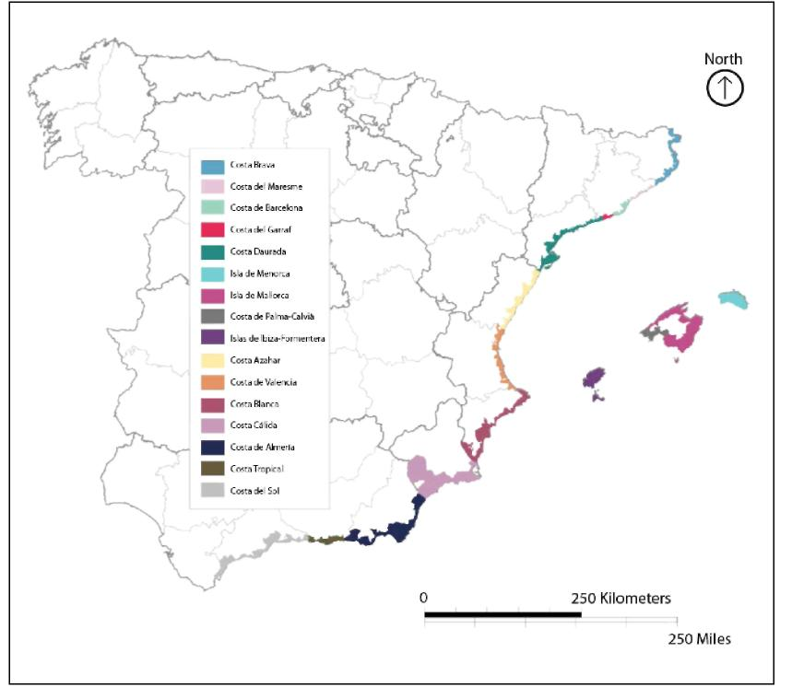
3. METHODOLOGICAL OUTLINE
According to the methodological approach developed in ESPON Climate, we will proceed with our case study on Mediterranean Spain following the concepts of exposure; sensitivity; adaptive capacity, and vulnerability. The combination of exposure and sensitivity creates impacts, while the combination of impacts and adaptive capacity yields vulnerability as a result. In this sense and along the objectives of the project, our main goal is to characterize the vulnerability of the tourist areas of Coastal Mediterranean Spain (including the Balearic Islands) to water stress originating from climate change. Next, we will expand this methodology and characterize the concepts introduced above.
8

First of all, it is important to lay out the ESPON Climate methodological approach. Roughly, this approach is addressed to map at a European scale values for the key concepts outlined above. Total values for each component and subcomponents of vulnerability are obtained after the joint consideration of the value of the specific component or subcomponent for each case study, and the weighted value of this component or subcomponent which is common to all case studies and which was obtained by means of a Delphi Panel constituted by ESPON Committee members. Table 1 indicates the weighted values for the major components and subcomponents of the vulnerability matrix.
Table 1. Weighted values of different components and subcomponents of vulnerability to climate change
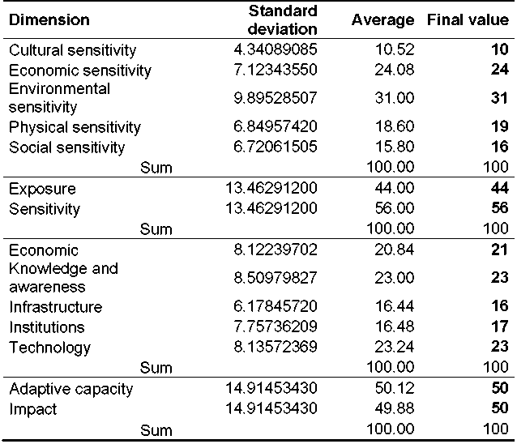
The next step was to select the components and subcomponents relevant for our case study, and the variables that could represent best these components and subcomponents taking into account data availability and quality at the desired spatial scales. Table 2 shows the variables chosen for each component and subcomponent of the vulnerability assessment exercise for our study areas of coastal Mediterranean Spain while figure 2 indicates weights for each component and subcomponent.
9

Table 2. Components, subcomponents and variables for assessing the vulnerability to climate induced water shortages in Mediterranean Spain
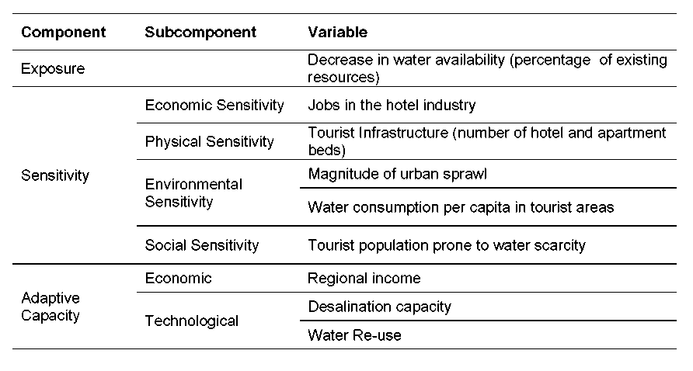
Figure 2. Dimensions included in the vulnerability index with the respective weights and the variables used
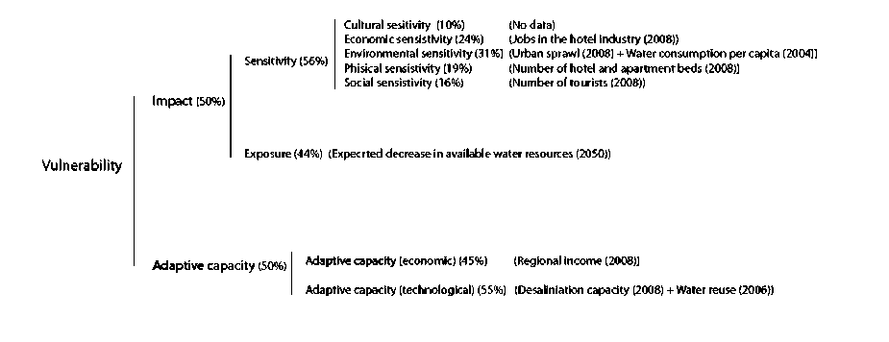
Accordingly, the methodological approach followed in this study can be divided into 4 stages:
- Definition of the variables used to calculate each dimension and compilation of relevant data.
- Assignment of a weight to each dimension according to the standard values established in ESPON Climate project and the availability of data. We have assumed an error in the global calculation of the sensitivity due to the lack of pertinent data regarding cultural sensitivity (given a value of “0”), and the lack of data regarding water consumption for the Costa de Azahar tourist area (variable used to calculate environmental sensitivity).
10

- Establishment of different ranks for each variable to calculate the value of each dimension for each “tourist zone”. The impact of climate change in the Mediterranean coast of Spain has been calculated taking into account 2 dimensions: exposure and sensitivity. While exposure has been defined according to the expected decrease in available water resources, sensitivity has been calculated as a sum of economic sensitivity (jobs in hotel industry), environmental sensitivity (urban sprawl + water consumption), physical sensitivity (number of hotels and apartment beds) and social sensitivity (number of tourists). Adaptive capacity has been calculated taking into account 2 dimensions: economic and technological adaptive capacity, with relative weights of 45% and 55%. Finally, the vulnerability is the result of the sum of the impact and the adaptive capacity.
- Mapping of each dimension. The legend of the summary maps (exposure, sensitivity, impact, adaptive capacity and final vulnerability) is set to represent values between 0 and 1 that indicate qualitative assessments (i.e. “low”, “medium” and ”high”).
4. VULNERABILITY ASSESSMENT
4.1. Exposure
According to the IPCC and to the Spanish Meteorological Agency (Aemet), Climate Change is likely to produce a negative effect on the existing water resources of the Spanish Mediterranean Coast. Models indicate that the increase in mean temperature (and therefore of evapotranspiration) and especially the reduction in precipitation (up to 20 per cent towards the end of the 21st century) may add important stresses on the population and economic activities, especially agriculture and tourism. The decline in precipitation would be more intense in the southern parts of the study area. Presently (IPCC, 2007), Spain enjoys a resource availability of water per person per year estimated in 3,000 m³/person/year, for a demand of 2,000 m³/person/year. At the end of the 21st century, the IPCC estimates that water availability would be reduced to just 450 m³/person/year, for demands moderately higher than today. It is likely that this reduction will affect especially the Spanish Mediterranean coast.
The modification of current climatic conditions produces changes in the hydrological cycle and consequently in the availability of water resources. Hence, variations in climate can be translated into variations in total annual runoff. For example, an increase in the frequency of droughts will not only result in less rain but also in increases in evapotranspiration and therefore in runoff reductions. The aim of this section is therefore, to provide some figures regarding the future availability of water resources for the tourist sector in our study area. These figures give an indication of likely physical scarcity conditions which will have to be integrated with sensitivity and adaptive capacity to produce a vulnerability assessment of the Spanish Mediterranean coast towards water scarcity situations induced by climate change.
11

Our indicators in this case will be those climatic stimuli that are relevant for the estimation of the amount of surface water and groundwater potentially available for supplying the tourist demand of our study area. The climatic stimuli selected are precipitation, temperature and evaporation.
The Spanish Meteorological Agency published in 2009 a report, "Generation of regionalized climate change scenarios for Spain,” which presented future climate scenarios generated from some European research projects on climate, particularly PRUDENCE ((Aemet 2009). These projections included data on maximum and minimum temperatures and on precipitation patterns, using 10 regional models developed through the downscaling of 5 global models, and using two emissions scenarios, A2 and B2. Whatever the emissions scenario, the global model, the technique of regionalization or the regional climate model used, all these projections observed rising temperatures throughout the 21st century for the Iberian Peninsula. However, our study area shows temperature increases significantly more moderate than those of the interior of the Iberian Peninsula, because of maritime effects in regulating thermal conditions.
For the 2011-2040 period, emission scenarios show little influence on the increasing temperature, while in the last period (2071-2100) the differences are substantial, with increases more marked for A2 than for B2. On the other hand, there is also a significant pattern within the year (seasonality), with increases much more pronounced in summer than in winter and early spring. Increases in the Spanish Mediterranean coast for 2071-2100, compared with 1961-1990, are approximately 1.5 to 3 º C in March for the Catalan, Valencia and Cadiz (Andalusia) areas, and more than 7 º C in August in the Balearic Islands and the Catalan coast. All these projections appear to have a high degree of confidence and spatial and temporal coherence. Given these figures, a significant increase in evapotranspiration, very noticeable in summer, is expected. Precipitation presents more mixed results. During the first half of the 21st century there is no clear signal in any direction. However, in the second half of the century average precipitation in Peninsular Spain may decrease between 15 and 30 percent with respect to the values of 1961-1990.
At the Spanish level, several assessments have attempted to predict reductions of water flows as a consequence of climate change. The White Paper on Water in Spain (2001) calculated a reduction of water for irrigation in the river basins of the Spanish Mediterranean coast. By 2030, that decrease would be of between 3 and 31 percent in the Catalan Inner Basins; 9 and 22 per cent in the Júcar basin, 11 and 28 percent in the Segura basin, and 3 and 31 per cent in the Andalusian basins. These scenarios were determined after the pessimistic projections of the mid to late 1990s when the river basin plans were being developed. Some authors estimated reductions in water flows in the study area of more than 30 per cent with respect to historic averages (Ayala-Carcedo and Iglesias , 2000).
More recent studies soften somewhat these grim predictions. Thus, the Spanish Plan for Adaptation to Climate Change (2006) calculated a reduction of between 5 and 11%
12

for the different river basins in the Spanish Mediterranean coast towards the middle of the century. These figures were included in the review of river basin management plans undertaken by the Ministry of Environment. The results of the application of hydrological models, such as SIMPA, by the Centre for Hydrographic Studies (CEDEX), to climate data indicate overall reductions in water availability. More specifically, the average runoff in Spain will decrease from 75 mm to 25 mm at the end of this century under a standard scenario.
Some regional organizations have generated, in turn, climate scenarios and hydrological forecasts. For example, in Catalonia, a report by the Catalan Water Agency foresees a reduction in water resources from 495 hm³ to 420 hm³ (15 percent), throughout this century with a more noticeable decrease in the second half (Cunillera et al 2009).
For the central sector of the Spanish Mediterranean coast, occupied by the Jucar and Segura basins, Quereda et al. (2009) have developed two possible scenarios of water resources behavior for the year 2030 that considers changes in runoff (see table 3). The first scenario envisages an increase of 1ºC in mean annual temperature and no change in precipitation patterns. Under these climatic conditions, the Jucar and Segura basins would experience a reduction of 12 percent (550 hm³/year) of their water resources currently estimated in 4,596 hm³/year. The second scenario implies a temperature rise of 1ºC and a reduction of 5 percent in average rainfall. This reduction would be translated into a runoff of only 57.6 mm, that is, 23 percent lower than the actual runoff of 74.3 mm. In turn, water available would fall 22 percent or over a 1000 hm³/year.
Under both scenarios but especially the second, the availability of water resource would cover at best 60 percent of the estimated water demand in 2020, put in some 7000 hm³/year according to the Jucar and Segura river basin plans.
Table 3. Decrease in average runoff in the Jucar and Segura basins, 2030 (Source: Quereda et al., 2009)
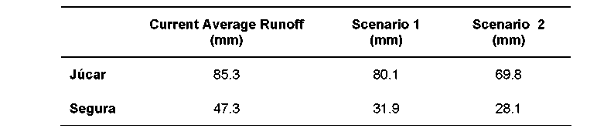
Until more detailed figures on water availability reduction may be generated by modeling, it appears reasonable to assume a gradual trend in which water in rivers and aquifers in our study area may decrease 5 per cent in the period 2011-2020; 10 percent for the two following decades; 15 percent for the decades 2041-2050, and 2051-2060, and at least 20 per cent for the remaining decades of the 21st century. Generally, reductions in runoff will have a clear latitudinal component. Reductions in
13

summer may double annual reductions while reductions in winter and perhaps in autumn may be minimal, especially in the more Northern basins. For the purposes of this study and taking into account all the estimations presented above we assume the latitudinal decrease in the availability of water resources appearing in all sources and we quantify this decrease to be of 5 percent in the tourist of Catalonia and the Balearic Islands (low decrease); of 10 percent in the tourist areas of Valencia, except for the Costa Blanca (medium decrease), and of 15 percent in the tourist areas of Costa Blanca, Costa Cálida and Andalusia (high decrease). In figure 3 we represent the corresponding map of this variable.
Figure 3. Map of decrease in available water resources around 2050 with respect to average values for 1961-1990 (Exposure)
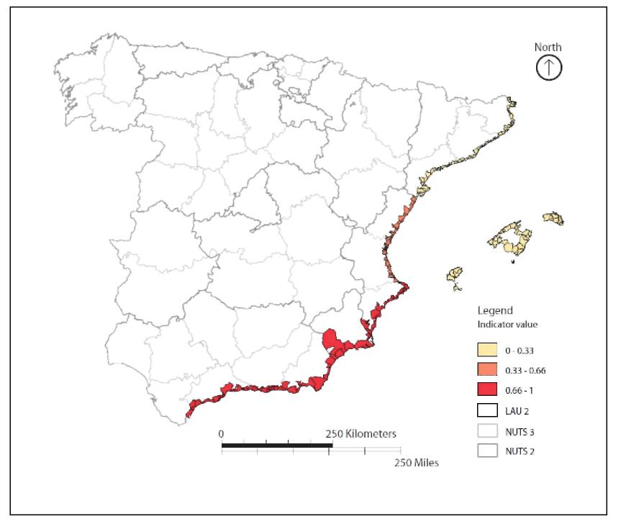
4.2. Sensitivity
Sensitivity indicators pretend to measure the susceptibility of the tourist sector to the climatic stimuli introduced in the exposure dimension. In our case study sensitivity indicators attempt to assess the effects for the tourist sector of a decrease in water availability induced by climate change. We suggest five indicators which, according to the taxonomy developed in this project, fall within the categories of physical sensitivity;
14

environmental sensitivity; social sensitivity, and economic sensitivity. In what concerns physical sensitivity we have chosen one indicator which is tourist infrastructure (measured as the total number of hotel and apartment beds in each tourist area). Environmental sensitivity is assessed through the variables urban sprawl (measured as the percentage of disperse urban land over the total of urban land), and water consumption, (water consumption per capita per day for each tourist area). The indicator chosen for social sensitivity is the total number of tourists in hotels that could be potentially affected by water shortages. Finally, economic sensitivity is measured by the number of jobs in hotels potentially threatened by the decline in tourist numbers that would follow a period or periods of water shortages.
The results of our sensitivity analysis are presented in figure 15. Prior to this analysis, however, we want to highlight the relevance of this area in terms of population and economic activity. The Spanish Mediterranean coast concentrated more than 9 million people in 2009 (about a quarter of the total population of Spain) (see figure 4). The regions of Catalonia, Valencia, Balearic Islands and Murcia, whose more active economic areas are located within our study area, represent more than a third of the Spanish GDP in 2008. In what concerns population change, the study area observed a 31 percent increase between 2000 and 2009, mostly attributable to immigration (see figures 5 and 6). Population growth in the study area doubles that of Spain and is between 6 and 7 times higher than that of Europe in the same period.
Figure 4. Population of the tourist zones (2009)
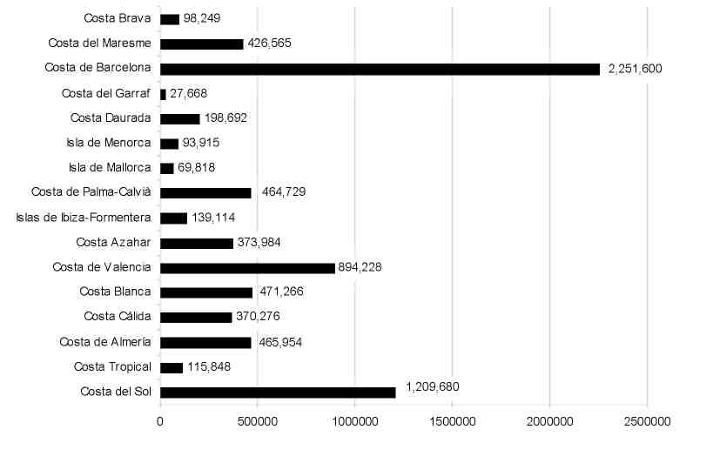
15

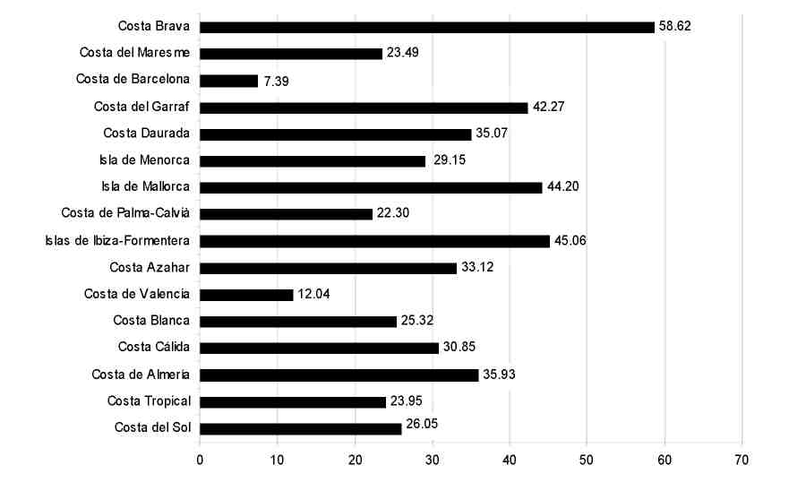
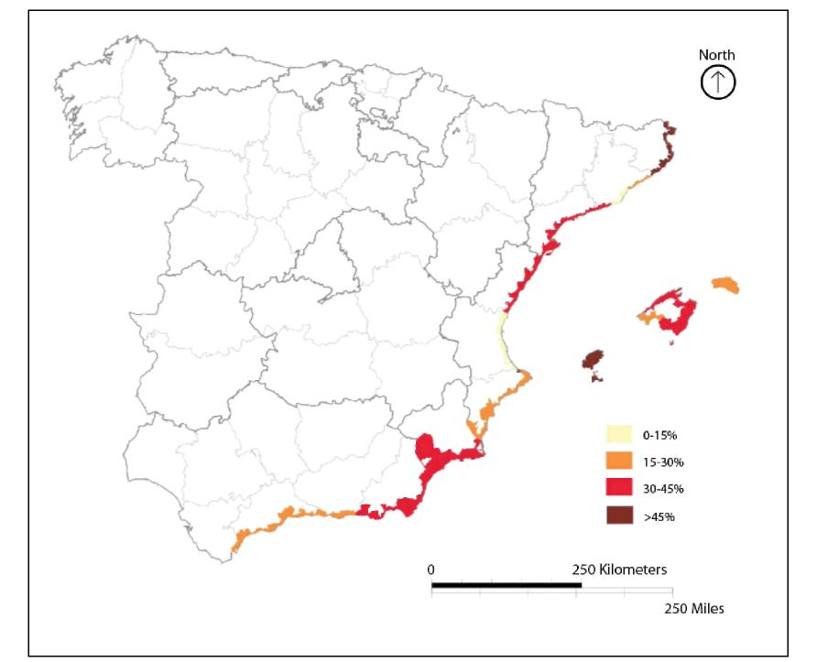
Figure 5. Population growth in the tourist zones (percent) (2000-2009)
Figure 6. Map of population growth in the tourist zones (percent) (2000-2009)
16

As said before, physical sensitivity is expressed through tourist infrastructure (number of beds in hotels and apartments) (see figure 7). In this respect, there are some 860,000 hotel and apartment beds in our study area, ranging from more than 217,000 in the Balearic Islands to slightly above 5,000 in the Garraf area (south of Barcelona) or in the Costa Tropical of Granada. Most areas approach or exceed 75,000 beds and a few (Costa del Sol, for instance) exceed 100,000 beds. Social sensitivity is reflected through the indicator number of tourists (see figure 8). Our study area shows the highest tourist concentration of the entire Mediterranean Basin with more than 26 million tourists in hotels alone in 2008. The most important single destination is Barcelona with 5.6 visitors, but, taken together, the Balearic destinations attained over 6 million tourists in 2008. Regarding environmental sensitivity and with the exception of the consolidated metropolises of Barcelona and Valencia, urban expansion in our study area during the recent decades has taken mainly a sprawled form (figures 9 and 10). Tourist areas such as the Costa Brava, the Costa del Sol, and much of the Balearic Islands maintain a disperse pattern of settlement with higher water consumptions per capita than the more compact areas (figures 11 and 12). Sprawled areas could therefore show a greater sensitivity to water shortages than compact areas because of larger and more varied water uses. Finally and regarding economic sensitivity as measured trough the number of jobs in the hotel industry, there are almost 100,000 jobs in our study area with important concentrations in the Balearic Islands (over 35 per cent of the total), Costa del Sol, and Barcelona (see figures 13 and 14).
17

Figure 7. Map of number of beds in hotels and apartments (2008) (Physical sensitivity)
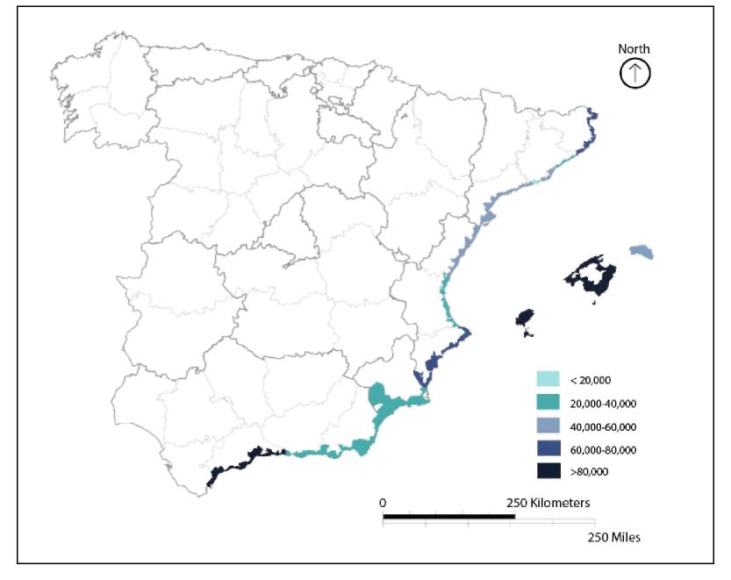
18
Figure 8. Number of tourists in the different tourist areas (2008) (Social sensitivity)
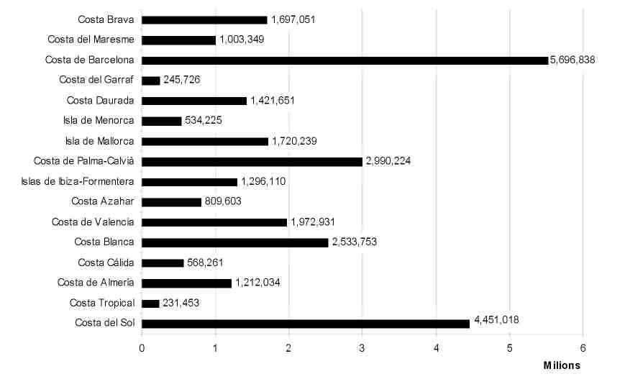

Figure 9. Urban land in the different tourist areas (km²) (2006) (Environmental sensitivity)
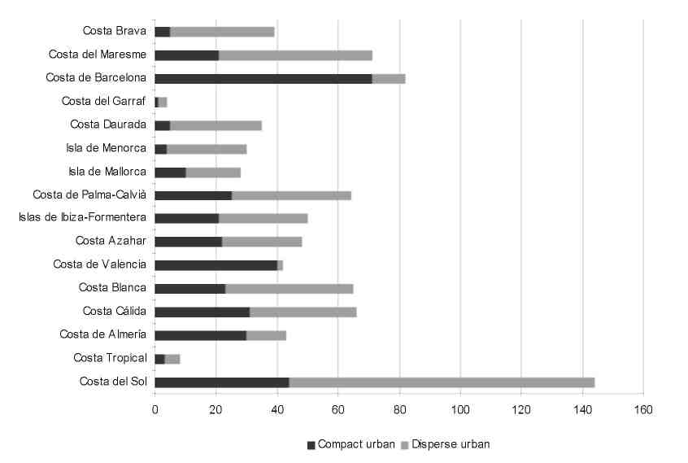
Figure 10. Map of urban sprawl in the different tourist areas expressed as percentage of disperse urban land/total urban land (2006) (Environmental sensitivity)
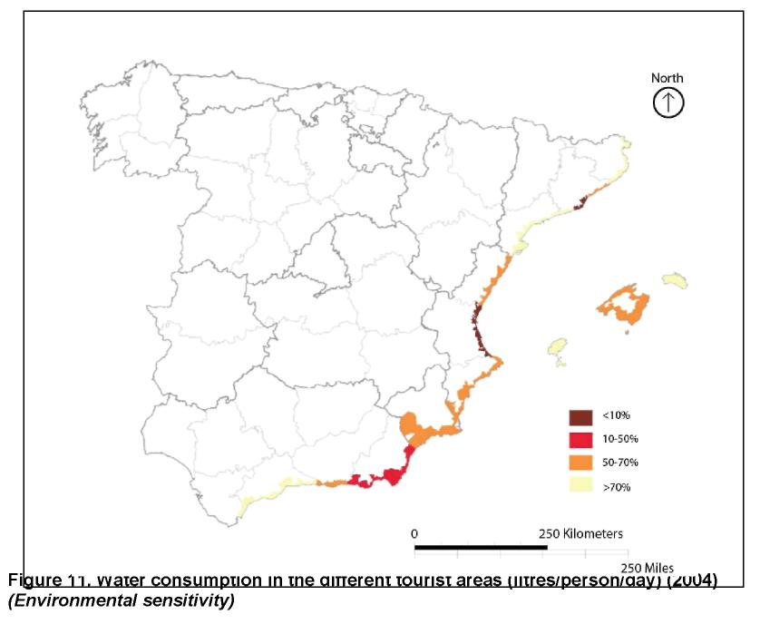

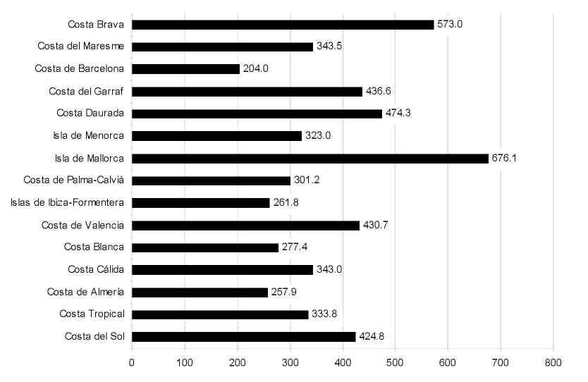
20
Figure 12. Map of water consumption in the different tourist areas (litres/person/day) (2004) (Environmental sensitivity)
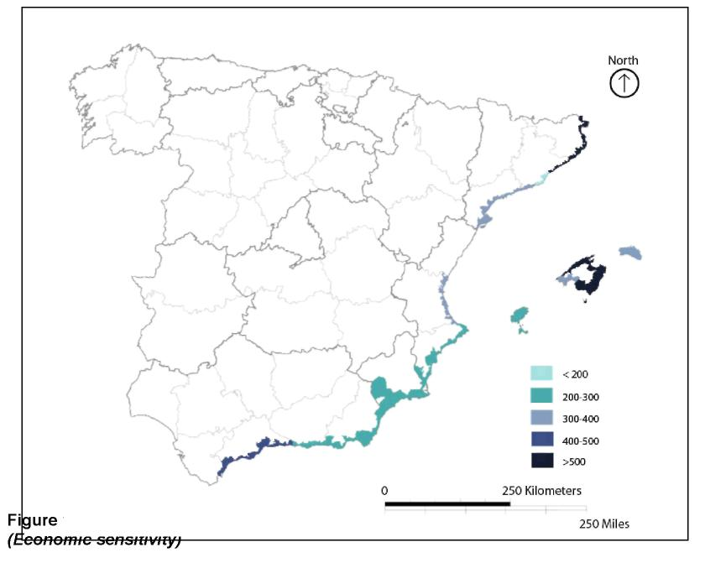

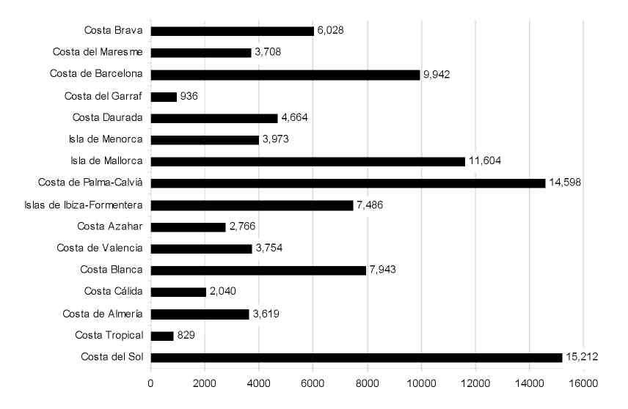
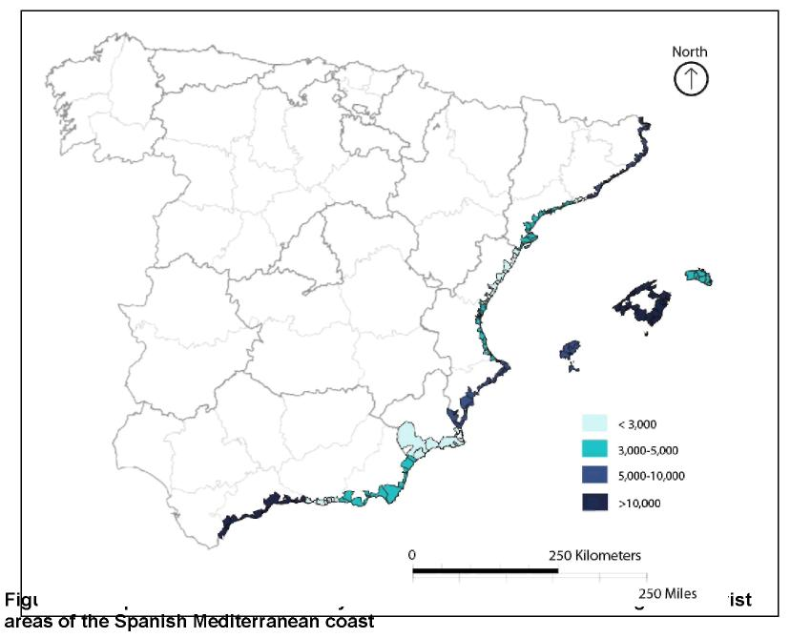
21

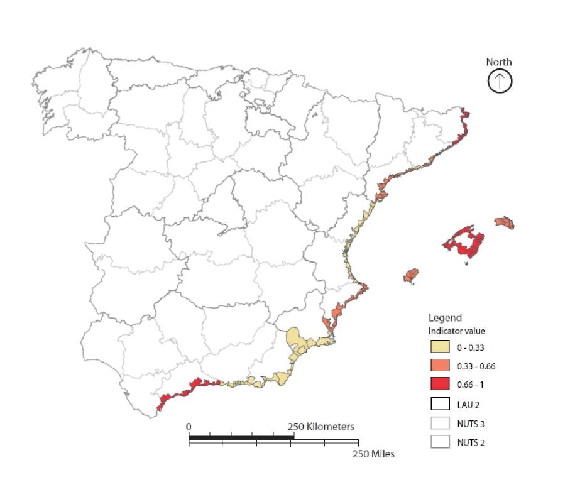
22

4.3. Impact
As said, impacts result from the combination between exposure and sensitivity (see figure 16). In this case, high impacts are only recorded for the Costa del Sol tourist area where high exposure is coupled with high sensitivity as this is one of the most important tourist areas of Spain. The situation of the two Majorcan areas and of the Costa Brava area in the medium category obeys to high sensitivities since both areas are also at the top of the Spanish tourist industry.
23
Figure 16. Map of impacts of climate induced water shortages in tourist areas of the Spanish Mediterranean coast
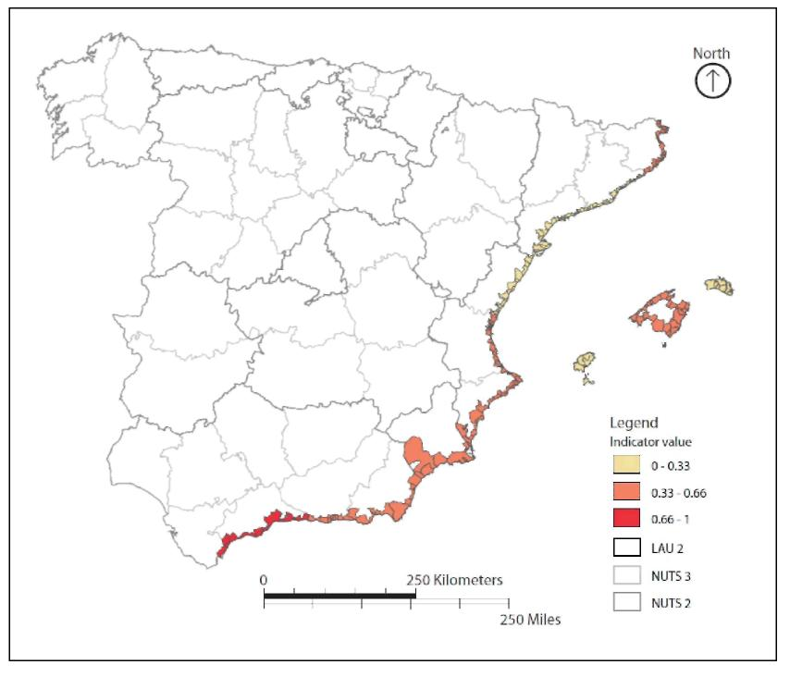

4.4. Adaptive Capacity
Adaptation capacity of the tourist areas to climate change and particularly to the effects of increasing water scarcity will depend strongly on the orientation taken by water planning and management in these areas as well as on the resources available to develop new water management options (e.g. money for new desalination plants) (see figure 22). The Spanish Mediterranean coast has suffered several episodes of water stress with important consequences on the tourist economy. We can recall here the cases of Benidorm in the late 1970s; of Majorca in the mid 1990s, or Barcelona in 2007-2008. Each of these episodes was solved by increasing and diversifying the sources of water supply, most notably through the construction of desalination plants. In fact, desalination is projected to expand considerably in the Mediterranean basin during the next years. The advantage of desalination is that it is climate independent and thus immune to droughts, although vulnerable to energy availability and price. If put to pertinent uses, treated wastewater may become an important resource for uses such as garden irrigation. But adaptive capacity may include also actions addressed to improve consumption habits among tourists such as the installation of efficient water fixtures in hotels or the design of landscaping adapted to local climatic conditions. In this respect and with the exception of hotels that may have some environmental certification, efficient water technologies in hotels are relatively scarce.
In our study area, adaptive capacity can also be evaluated through the evolution of daily per capita water consumption which (as reflected in figure 17) shows a decreasing trend during the period 2000-2008 in all cases for which there is available data. This decreasing trend may involve a large variety of factors not easy to differentiate but that probably include more efficient distribution networks, metering, and perhaps also better conservation attitudes by citizens especially during times of drought and structural demographic trends such as the higher proportion of immigrants and the elderly in certain metropolitan cores such as those of Barcelona and Valencia. However, we have considered this variable in the final calculations because of the paucity of data available.
Figure 22 represents the final map of adaptive capacity. The highest values are recorded for those tourist zones combining relatively high scores in new water technologies with high incomes whereas the lowest values indicate relatively low incomes and medium to low technological developments.
24

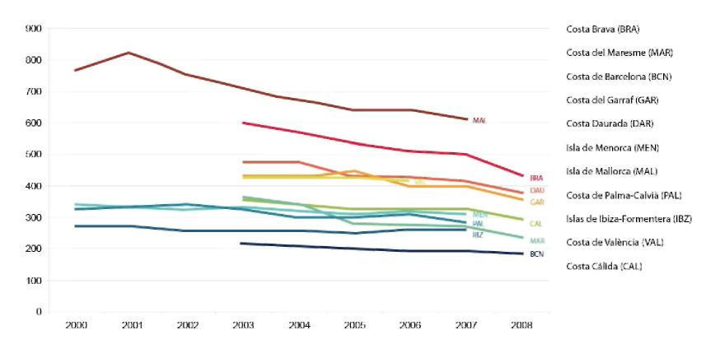
Figure 17. Trends in water consumption per capita in the different tourist areas (litres/person/day) (2000-2008)
In figure 18 we present data on desalination capacity which appears to be oversized in certain cases (Almeria and Costa Cálida) and still small in others (Valencia). The use of treated wastewater represents another interesting form of technological adaptation, and one that has received considerable attention in some of the tourist zones examined. In figure 19, indicating the percent of wastewater treated with advanced tertiary systems (that is, those giving qualities near pre-drinking stages) it can be seen how in many areas more than 50 percent of treated wastewater may be ready for certain uses (golf course irrigation, for instance) and that, in some cases (the Costa Brava and the Costa Blanca) it approaches 90 percent. Regarding income per capita (see figure 20 and 21), which is a standard proxy for economic adaptive capacity, shows a clear North-South gradient whereby only the tourist areas of Catalonia and the Balearic Islands show incomes higher than the European average. At the other extreme, the Southern areas of Murcia and Andalusia remain well below European average.
25

Figure 18. Desalination capacity in the different tourist areas (hm³) (Technological adaptive capacity)
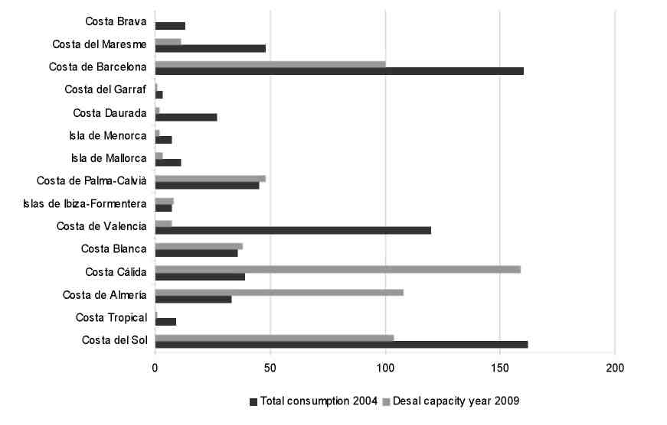
26
Figure 19. Percent of water reuse of treated wastewater in the different study areas (hm³) (2008) (Technological adaptive capacity)
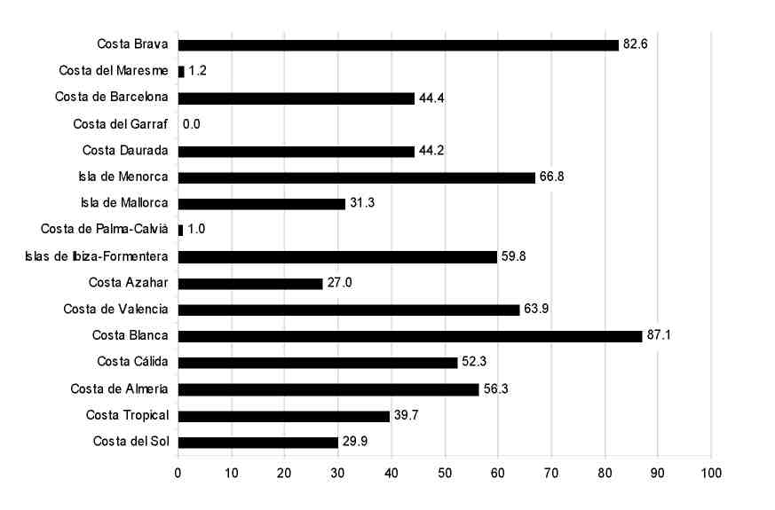

Figure 20. Average regional income per capita (Euros) (2008) (Economic adaptive capacity)
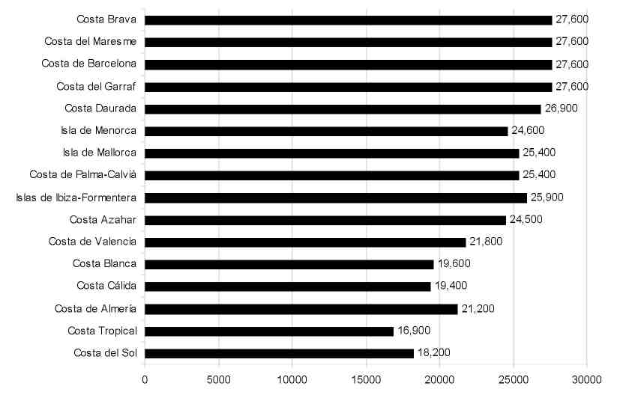
Figure 21. Map of average regional income (Euros) (2008) (Economic adaptive capacity)
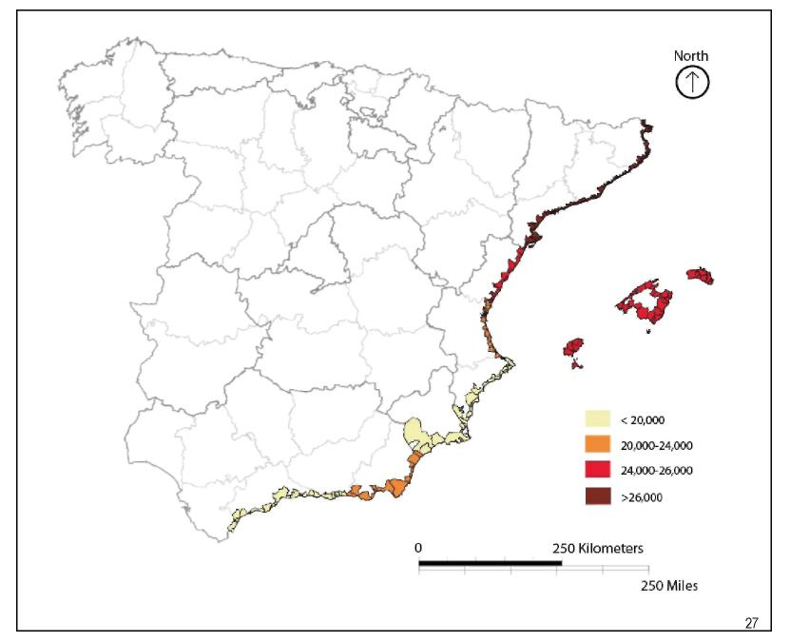

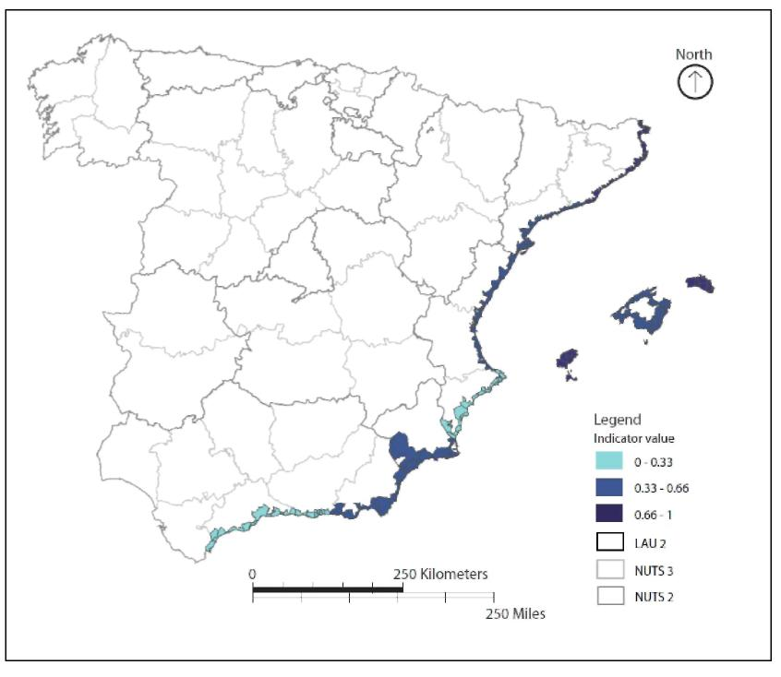
Figure 22. Map of adaptive capacity of the different tourist areas
28

4.5. Vulnerability
Vulnerability combines the aggregated impact indicator and the aggregated adaptive capacity indicator (see figure 23). Figure 23 shows the final results of our vulnerability assessment to climate induced water shortages for the different tourist areas of the Spanish Mediterranean coast (see also table 4). It can be seen how the highest values are found in the Costa del Sol, the Costa Tropical, and the Costa Blanca areas. The Costa del Sol and the Costa Tropical areas observe high exposures and a relatively low adaptive capacity, mostly because relatively low income. Furthermore, and given its strong tourist orientation the Costa del Sol ranks high in sensitivity to impacts. In the Costa Blanca high exposure is accompanied by a high sensitivity and a relatively low adaptive capacity, especially in what concerns income. However, it must be noted also the important presence of desalination and especially of water re-use. Medium vulnerability has been found for the tourist areas of the island of Mallorca, for Valencia, and for the Costa de Almeria and Costa Cálida areas. In this case, high sensitivities (especially in the Mallorca case) combine with medium exposures and medium to high adaptive capacities (note the large desalination capacity of the Costa de Almeria area, able to offset the low values attained in income). Finally, vulnerability is at its lowest in the tourist areas of Catalonia, and in the islands of Menorca and Ibiza. For this group, low exposure combines with medium to high sensibility and medium to high adaptive capacity resulting thus in a low vulnerability score.
Table 4. Qualitative summary of components of the vulnerability assessment to climate induced water shortages in the different tourist areas of the Spanish Mediterranean coast

Area | Exposur e | Sensitivit y | Impact | Adaptive capacity | Vulnerabili ty
Costa Brava | low | high | medium | high | low
Maresme | low | low | low | medium | low
Barcelona | low | medium | low | high | low
Garraf | low | low | low | medium | low
Costa Daurada | low | medium | low | medium | low
Menorca | low | medium | low | high | low
Mallorca | low | high | medium | medium | medium
Palma-Calvià | low | high | medium | medium | medium
Ibiza-Formentera | low | medium | low | high | low
Costa Azahar | medium | low | low | medium | low
Valencia | medium | low | medium | medium | medium
Costa Blanca | high | medium | medium | low | high
Costa Cálida | high | low | medium | medium | medium
29

Costa Almería high | low | medium | medium | medium
Costa  high  Tropical  Costa del Sol high | low high | medium high | low low | high high
30
Figure 23. Aggregated vulnerability map to climate induced water shortages of tourist areas in the Spanish Mediterranean Coast
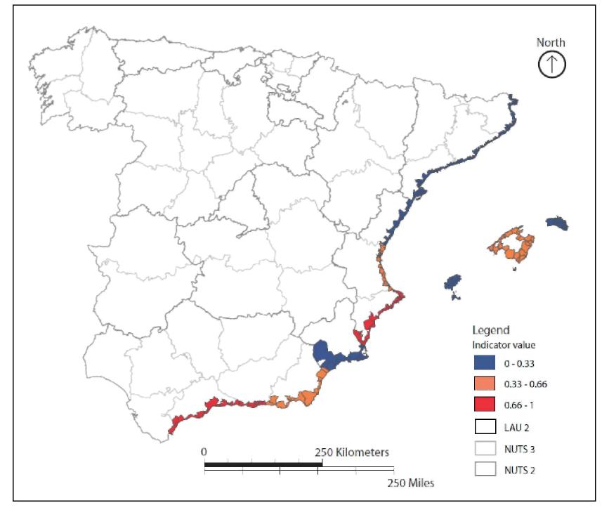

5. RESPONSE STRATEGIES AND POLICY DEVELOPMENT
Strategies and policy development to manage water scarcity due to climate change in tourist areas will be based on the previous vulnerability analysis. One important matter is whether the different European regions will have the capacity to access resources that are to a greater or lesser extent climate independent such as desalted water; treated wastewater or to resources traded with other large users, most especially irrigation. But, as said before, adaptive capacity may include other measures such as an overall reduction in per capita use in the tourist industry after the implementation of water saving technologies in hotels or of landscaping practices avoiding species with high water requirements.
Regarding the case of the study area, responses to vulnerability to water shortages induced by climate change must be seen also in the light of the National and Regional Mitigation and Adaptation Strategies currently being developed in Spain. This the Spanish National State and the different Comunidades Autónomas (regional governments) all have issued mitigation and adaptation documents (the latter still very incipient for certain areas), The National Adaptation Strategy of 2006 implied the elaboration of vulnerability assessments for 15 different natural and socioeconomic sectors, four of which (water resources, coastal areas, tourism, and urbanism and the built environment) are especially relevant for our case study. Spatial planning, especially at local and regional scales, is central to the reduction of vulnerabilities in these four areas. Land use regulations, setting for example limits to the expansion of urban and tourist developments, above all those of a sprawling nature, are envisaged a mitigation tool (for example, in managing urban and tourist growth through urban planning tools the proliferation of gardens planted by high water consumption species, swimming pools or golf courses may be put under control) or as adaptation (land use regulations may also consider the design of gardens and golf courses using species adapted to climate). Nevertheless, it is likely that most of the adaptive actions addressed to redress the impact of climate change on the existing water resources in coastal Mediterranean Spain will likely follow the course of new water producing technologies such as those outlined above.
6. VALIDITY FOR THE PAN-EUROPEAN ASSESSMENT
The case study and especially its results need also validation regarding the results of the pan European assessment on exposure, sensitivity, impacts, adaptive capacity and vulnerability. Values for most of these dimensions at the European scale give our study area a rather problematic picture. Exposure to climate change tends to be high, sensitivity tends to be high as well; in consequence impacts are high and adaptive capacity tends to be low at least in comparison with other European regions. Nevertheless it is also true that coastal Mediterranean Spain fares slightly better than other regions located in the South and in the East of the continent regarding adaptive
31

capacity. Moreover, the Pan European Assessment maps tend to reflect also the differences within our study area which roughly follow a North-South gradient, especially regarding exposure, impacts, and adaptive capacity. In this sense then there appear to be a basic coincidence between the findings of the Pan European assessment and those of our case study regarding these variables. However, there are some differences which are obvious in the case of Barcelona. This is due to the fact that the pan-European assessment considers additional dimensions such as social: the sensitivity of the agglomeration of Barcelona to urban heat influences the overall picture considerably.
Some of the findings of our case study also corroborate findings obtained in other case studies. This is particularly true for the case of those adaptive capacity actions that may produce unintended negative feedbacks. In the case study on the Alpine space, for instance, artificial snow-making could be considered as an adaptation to decreasing precipitation in winter which is critical for the tourist industry. However, this action may be costly in energy and environmental terms. Similarly, some of the adaptation actions to reduce climate induced water shortages (most notably desalinization) are energy intensive and may jeopardize the marine environment after the release of brine with extremely high concentrations of salt.
Both case studies reflect possible situations of “maladaptation” and therefore possible conflicts between mitigation and adaptation measures to which national and regional strategies on climate change, at least for the case of Spain, have not responded adequately yet
7. VALUE ADDED AND LESSONS LEARNED
The case study developed represents a relevant contribution in value added terms to climate change studies mainly because it is probably one of the first contributions that attempt to link explicitly climate change, water use and tourism using a number of variables for each topic and for a specific area. And it does so using and giving empirical content to the most important concepts developed in the IPCC reports (exposure, sensitivity, adaptive capacity, vulnerability). Moreover, it is also relevant because of the spatial scale of analysis used offering an important level of detail (data resolution is at the supra-municipal level in most cases).
Perhaps the most important lesson learned in this case study is that climate change may have an important impact on the water resources used by the tourist sector in the area studied and that this activity needs to develop effective adaptation measures, preferably in the area of increasing efficiency in use via technological, economic or behavioural changes. Another important lesson is that climate change mitigation policies in the case of tourism need to take seriously into account urban patterns of development (compact or disperse) since they may exert considerable influences on emissions. Finally, in our case study it is important to emphasize the coincidence of
32

areas which, on the one hand, are highly exposed and, on the other, show relatively low degrees of adaptive capacity (at least in what concerns income).
8. TRANSFERABILITY OF CASE STUDY RESULTS AND METHODOLOGY TO
OTHER SIMILAR EUROPEAN REGIONS
The methodology used and the result obtained may be of interests for other European tourist areas, especially those oriented towards summer mass tourism. Temperature increase and precipitation decline are common features of future climate scenarios in the Mediterranean and expected trends may be especially intense in the Central and Eastern shores (the Balkans, Turkey, the Greek islands, etc.) precisely where numerous mass tourism complexes have been developed in the recent past and now attract growing numbers of tourists. By identifying exposure conditions, the sensibility of the tourist sector to likely episodes of water scarcity, and the range of choice among different adaptation strategies (or a combination of these) after the framework proposed for the Spanish Mediterranean coasts, these areas could also develop appraisals of their vulnerability to climate induced water shortages. It is important to have at least some regionalization of temperature and precipitation trends, information on the tourist sector (especially on their economic significance for the region), and also information on the range of choice for water management including supply side projects both conventional (dams, water transfers) and alternative (desalination, treated wastewater, buying of water rights from other sectors), and demand side options (more efficient use of existing resources). Our results suggests that exposure and sensitivity of the tourist sector to water shortages induced by climate change are important in the Spanish Mediterranean coast but that the potential for adaptive capacity options is equally significant. However, some of the options in the area of adaptive capacity (desalination being the most obvious) could be also defined as “maladaptation” (see Barnett and O’Neill, 2010) since they shift the costs of enhancing water supplies to the energy sector. On the other hand, adaptations based on demand management (especially technology and behavior surrounding water efficiency and savings) are still incipient at least in the hotel sector.
9. CONCLUSIONS
The vulnerability assessment to possible water shortages induced by climate change in the Spanish Mediterranean coast developed in this report shows a distinct spatial pattern according to the combined dimensions of exposure, sensitivity and adaptive capacity, all weighted according to ESPON Climate experts. Generally, vulnerability tends to increase from North to South, mainly because of increasing exposure and decrease in adaptive capacity (especially in what concerns income) along this gradient. One extreme case is the Costa del Sol tourist area (one of the most important not only
33

of Spain but of the entire Mediterranean) where scores for exposure, sensitivity and adaptive capacity combine to produce the highest vulnerability of the study area. At the opposite side, certain areas of Catalonia observe low vulnerabilities after a combination of low exposure and high adaptive capacity. Another interesting case are the Balearic Islands which rank low in exposure but medium to high in sensitivity thus indicating the strategic importance of tourism for their economies. Adaptive capacity, however, is in principle high enough to offset sensitivity and the resulting vulnerability is low.
The variables selected and the method chosen may be useful for other tourist areas of the Mediterranean coast. Generally, one could assume an increase in the vulnerability of Mediterranean tourist areas along a gradient West-East due to increasing exposure, perhaps medium to high sensitivity (due to the enormous growth of the tourist industry in certain areas such as the Balkans or the Eastern coasts), and low to medium adaptive capacities which may change in the future if alternatives such as desalination (already present and growing in many Mediterranean countries) may be successfully implemented. However, sound adaptive capacities should move towards better water demand management in the tourist areas (to an important extent only possible through the management of urban growth). As seen in the case of Spain, this alternative is still in its infancy. Another interesting possibility for increasing the adaptive capacity of Mediterranean tourist areas would be to negotiate with farmers for water either saved by the modernization of irrigation channels or through exchanges of water of different qualities between agriculture and tourism.
REFERENCES
Aemet (Agencia Española de Meteorologia) 2009 : Generación de escenarios climáticos regionalizados para España. Available at: http://www.aemet.es/documentos/es/elclima/cambio_climat/escenarios/Infor me_Escenarios.pdf
Amelung , B., Nicholls, S., and Viner, D. 2007: Implications of Gklobal Climate Change on Tourist Flows and Seasonability, Journal of Travel Research, 45(3) 285-296.
Ayala Carcedo, F.J. and Iglesias, A. 2000. Impactos del posible cambio climático sobre los recursos hídricos, el diseño y la planificación hidrológica en la España Penínsular, BBVA, Servicio de estudios.
Barnett, J, and O’Neill, S. 2010: Maladaptation, Global Environmental Change, 20, 211-213.
Cunillera, J., Mas, J., Manzano, A., Prat, N., Munné, A. y Saurí D. eds 2009 “Aigua i Canvi Climàtic. Barcelona, Agència Catalana de l’Aigua (Generalitat de Catalunya).
Dubois, G. i Ceron, J.P. (2006): “Tourism and climate change: Proposals for a research agenda”, Journal of Sustainable Tourism, 14 (4): 399-415.
34

Gil Olcina, A. 2010: Optimización de recursos hídricos y armonización de sus usos: el Consorcio de Aguas de la Marina Baja, Investigaciones Geográficas, 51, 165-183
IPCC (2007), Climate Change 2007: Synthesis Report. Contribution of Working Groups I, II and III to the Fourth Assessment Report of the Intergovernmental Panel on Climate Change. Core Writing Team, Pachauri, R.K. and Reisinger, A. (Eds.). IPCC, Geneva, Switzerland. pp 104, online at: http://www.ipcc.ch/publications_and_data/publications_ipcc_fourth_assessment_rep ort_synthesis_report.htm
Rico-Amorós, A.M., Olcina-Cantos, J. Saurí, D. 2009 Tourist Land Use Patterns and Water Demand. Evidence from the Western Mediterranean, Land Use Policy, 26, 493-501.
Quereda, J. Montón, E. y Escrig J. (2009) Evaluación del cambio climático y de su impacto sobre los recursos hídricos en la cuenca del Júcar. Generalitat Valenciana. Fundación Agua y Progreso, Valencia, 165.

