

ESPON 2013 Programme

**ESPONTrain Final Transnational Conference**

**Are European planners familiar with ESPON findings?**

***Integrating ESPON in higher education and***

***policy making at central, regional and local levels***

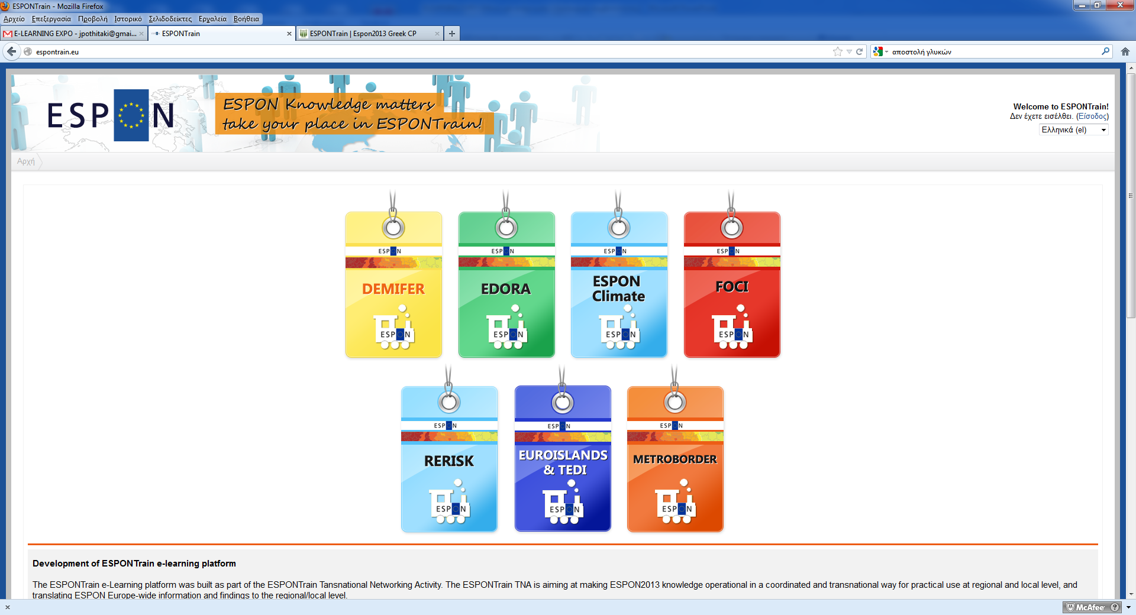

**3 & 4 April 2013**

**Venue : Panteion University**

**“Sakis Karagiorgas II” Amphitheater**

**136, Syngrou Ave., Kallithea**

**GR-176 71 - ATHENS**

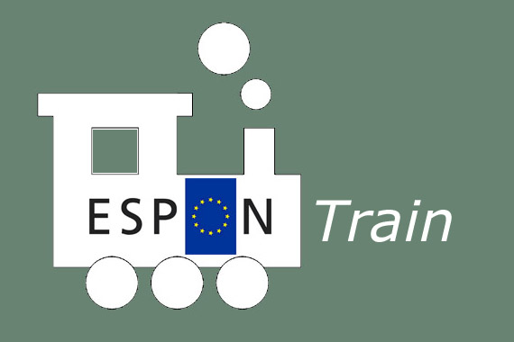

...

ESPON is a research programme providing data, concepts and techniques which can be used in the development of effective place-based policy.

colorful-banner4

Τhe ESPONTrain Final Transnational Conference is organized by the Greek ESPON European Contact Point in the framework of a joint programme designed **to stimulate interest on ESPON2013 knowledge** via a **Virtual Learning Environment.** ESPONTrain created an educational model and course design and delivered educational cycles for both post-graduate students and stakeholders in 10 ESPON Countries: Greece, Italy, Czech Republic, Lithuania, Estonia, Malta, Cyprus, Slovenia, Romania and Bulgaria. The 2-day Transnational ESPONTrain Conference consists of two main sections:

1. The transnational meeting of April 3 that will bring together the ESPON Coordination Unit, 10 ESPON European Contact Points (ECPs) participating in the ESPON Programme as well as trainers and trainees involved in the ESPONTrain Virtual Learning Environment Project. This first day will focus on the issue of using ESPON findings in higher education and in territorial development strategies. Participants will mostly come from higher education institutions, both professors and students as well as from state and regional authorities.
2. A conference open to the general public, particularly addressed to policy makers of central, regional and local levels to stimulate interest in further integration of the ESPON knowledge in the **implementation** of territorial development and cohesion in Southern Europe and the Mediterranean.

The ESPONTrain Conference aspires to promote dialogue between political leaders, policy makers, academics and professionals on the field of territorial development and cohesion and will be structured around the following topics:

- The progress of the ESPONTrain Project, its results, its evaluation as well as the perspectives of further development of the ESPONTrain VLE model in the ESPON countries.

- The use of ESPON findings in spatial planning and in territorial development focusing on European cities and regions

- The ongoing spatial and urban planning reform in Greece and in other ESPON countries and particularly in relation to the use of the ESPON findings.

- The profile of European planners (qualifications, skills, etc.) required to meet the challenges of territorial development and cohesion in Europe and the necessary innovation that ESPON can bring in its education.

**Programme**

***3rd of April 2013 : «ESPON findings in spatial planning and in territorial development strategies»***

**12:00** Registration of participants

**12:20** Welcome by **Ismini Kriari,** Professor, Vice Rector of Academic Affairs at Panteion University

**12:30 Antonia Moropoulou**, Professor, Vice Rector of National technical University of Athens

**12:40 Kostis Hatzidakis,** Minister of Development, Competitiveness, Transport, Infrastructure and Networks (tbc)

**12:50 Stavros Kalafatis,** Deputy Minister of Environment, Energy and Climate Change (tbc)

**13:00** **Antigoni Lymberaki,** Professor, President of the Academic Council of the National Center of Public Administration, Greek ESPON Contact Point Expert

**13:10 Peter Billing,** ESPON Coordination Unit

***“ESPONTrain - An innovative dissemination tool within the larger context of ESPON”***

**13:30** **Stella Kyvelou**, Asst Professor, Panteion University, Director, ESPON Contact Point in Greece & **Symeon Retalis,** Professor, Piraeus University

***«The ESPONTrain Virtual Learning Environment: concept, structure and lessons learned”***

**14:00** Break for light buffet

**14:50** Round Table 1: ***“Evaluating ESPONTrain Project in the participating countries”***

Moderator: **Mathilde Konstantopoulou**,ESPON Monitoring Committee member, Greece

Rapporteur: **Peter Billing**, ESPON CU

Participants: **Representatives of all partners ( RO, IT, ES, LT, GR, MT, CY, CZ )**

**16:20** Round Table 2: ***“Using ESPON findings : How can ESPON influence national systems of spatial planning and territorial development strategies of regions and cities ?”***

Moderator:  **Nikitas Chiotinis**,Greek ECP

Rapporteur: **Alexandru Rusu**, Romanian ECP

Participants: **Maro Evangelidou,** Secretary General of Environment, Energy and Climate Change, **Maria Karaklioumi,** Vice Governor, Region of Attica, **Maria Prezioso,** Professor, University of Rome Tor Vergata, ECP Italy, **Minas Angelidis**, Professor, National Technical University of Athens, **Ashley Farrugia,** Malta Environment and Planning Agency, ECP Malta

**SCIENTIFIC RESPONSIBILITY**

Stella Kyvelou, Asst Professor, Panteion University, ESPON Contact Point, Greece

Maria Prezioso, Professor, University of Rome TOR Vergata, ESPON Contact Point, Italy

**CONFERENCE ORGANISATION**

***Stella Kyvelou***, Panteion University, Greek ECP, ***Nektaria Marava***, PhD Candidate, ESPONTrain, Greece, ***Nikitas Chiotinis***, Professor, Greek ECP, ***Ioanna Pothitaki***, Panteion University, Greek ECP, ***Evi Koloniati***, Panteion University, Greek ECP, ***Leonidas Maroulis***, Panteion University, Greek ECP, ***Antonis Varotsos***, Panteion University, ***Nikos Patselis***, Panteion University, Greek ECP, ***Andreas Bitsakos***, PhD Candidate, Panteion University, ***Popi Tzevelekou***, Panteion University, Greek ECP

**17:50** Coffee Break

**18:10** Round Table 3 : ”***European planners meeting territorial development challenges. What qualifications are needed?****”*

Moderator: **Marija Buriskiene**, Lithuanian ECP

Rapporteur: **Antti Roose**, Estonian ECP

Participants: **Peter Biling,** ESPON Expert, ESPON Coordination Unit, **Yannis Psycharis,** Ass. Professor, Panteion University, ex.Director of National School of Local Government, **Daniel Tudora**, University Alexandru Ioan Cuza, RO, **Sofia Avgerinou-Kolonia,** Professor, National Technical University of Athens, **Elissavet Thoidou,** Asst Professor, Aristotle University of Thessaloniki, **Αthina Mourmouri**, Director General, Ministry of Environment, Energy and Climate Change, member of the teaching staff of the National Center of Public Administration

**19:40**  Open discussion and conclusions

**20:00** End of Conference

***4th of April 2013: «ESPON and the ongoing reforms of urban and spatial planning»***

**09:00** Registration

**09:30** Feedback from Round Tables by the rapporteurs

**10:10 Peter Billing,** ESPON Coordination Unit,

**“*ESPON 2013 Programme – Status and Prospects”***

**10.30** Round Table 1:***“Spatial and urban planning reforms in Europe: Is crisis a challenge for a better coordinated territorial development between central, regional and local levels?”***

Moderator: **Pericles Vassilopoulos,** Journalist, Vice President of « Paremvassi »

Participants:

**Spyros Spyridon**, Regional Counsellor, Region of Attica

**Maria Prezioso,** Professor, University of Rome TOR Vergata, Italian ECP

**Minas Angelidis,** Professor, National Technical University of Athens

**Akis Leledakis,** Asst Professor, Panteion University

**Stella Kyvelou,** Asst Professor, Panteion University, Greek ECP

**12:00** Break

**12:30** Round Table 2: ***“A new European planner for the European territory of tomorrow?”***

Moderator : **Peter Billing**, ESPON Coordination Unit

Participants : **Representatives/Trainers of all ESPONTrain participants**

**14:30** Open discussion, conclusion and end of conference

**15:00** Lunch buffet or ESPONTrain Project Partners

**16:00** ESPONTrain Internal Meeting “Towards the ESPONTrain Final Report”

Where can I find out more?

More information on ESPON and on all its research outputs can be accessed via the ESPON website www.espon.eu.

**For more information :**

**Contact us**

ESPON CONTACT POINT- Panteion University of Social and Political Sciences of Athens

136 Syngrou Ave

Athens 176 71

Greece

Email espon2013\_ncp@panteion.gr

Telephone 0030 210 9236206

The ESPON Programme’s main aim is to support planning policy development and territorial cohesion. Current research is focused on the driving forces shaping Europe such as:

Knowledge and innovation

Climate change

Energy poverty

Migration

Accessibility

Globalisation

ESPON provides territorial development concepts that can be adapted to specific situations in each participating state. It allows benchmarking against European regions and can therefore act as a platform for developing policies aimed at territorial cohesion.

**The ESPONTrain Project**

The ESPONTrain Project is aiming at making ESPON2013 knowledge operational in a coordinated and transnational way for practical use at regional and local level, and translating ESPON Europe-wide information and findings to the regional/local level.

The main thematic teaching packages, based on the ESPON Projects, are the following:

1. Migration-demography ([DEMIFER](http://www.espon.eu/main/Menu_Projects/Menu_AppliedResearch/demifer.html))
2. Rural ([EDORA](http://www.espon.eu/main/Menu_Projects/Menu_AppliedResearch/edora.html))
3. Energy - Climate change and other risks ([ReRISK](http://www.espon.eu/main/Menu_Projects/Menu_AppliedResearch/rerisk.html" \t "_self) and [ESPON Climate](http://www.espon.eu/main/Menu_Projects/Menu_AppliedResearch/climate.html))
4. Urban & Agglomeration economies ([FOCI](http://www.espon.eu/main/Menu_Projects/Menu_AppliedResearch/foci.html) )
5. Types of specific territories ([EUROISLANDS](http://www.espon.eu/main/Menu_Projects/Menu_TargetedAnalyses/EUROISLANDS.html) and [TeDI](http://www.espon.eu/main/Menu_Projects/Menu_TargetedAnalyses/espontedi.html))
6. Territorial cooperation - Governance building ([METROBORDER](http://www.espon.eu/main/Menu_Projects/Menu_TargetedAnalyses/metroborder.html))

For more information on ESPONTrain, have a look at the project’s website http://espontrain.eu

**GR ESPON Contact Point**

There is a Contact Point in each of the states involved in the ESPON 2013 Programme. In Greece, the Contact Point service is provided by Panteion University of Social and Political Sciences of Athens. Valuable information on ESPON research in Greece can be found on the Greek ESPON Contact Point’s website www.espon2013.panteion.gr.

ESPONTrain’s ten partners

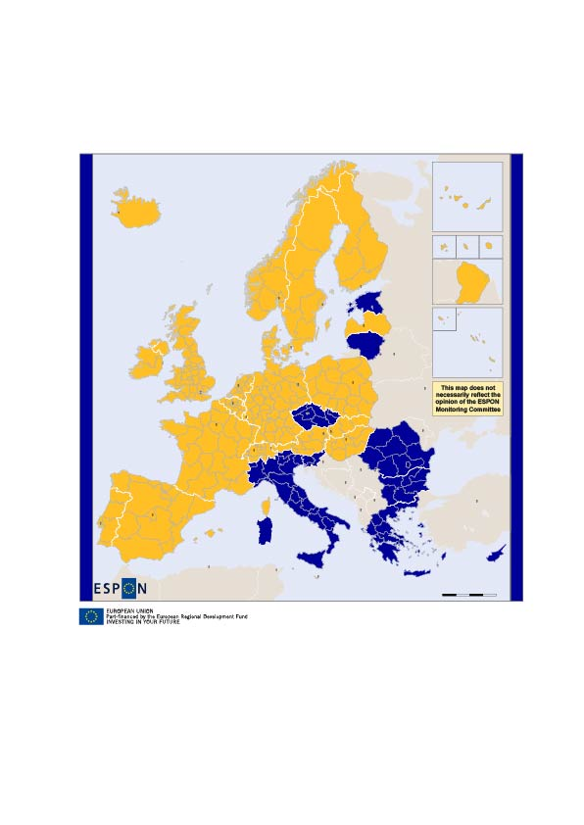

colorful-banner4